CONTEXT

Vattenfall, as a leading European energy provider, operates in a rapidly evolving energy landscape shaped by accelerating digital transformation, technological advancements, and sustainability requirements. Within this broader context, the Business Unit E-Mobility plays a critical role in achieving Vattenfall's strategic objectives by driving innovation in electric vehicle (EV) infrastructure, digital services, and hardware solutions.

The Digital Services & Hardware (DSH) department within the BU E-Mobility is at the heart of this transformation. The DSH team faces both challenges and opportunities including the rapid pace of technological innovation, evolving customer expectations, increased competition in the EV market, and the need for digital excellence. Successfully navigating these dynamics requires a clear, compelling technology vision, clear roadmaps, robust leadership, new ways-of-working and high team performance.

Given the market's current momentum - particularly the rapid integration of AI, increased focus on customer experience, hardware standardization, and strategic partnerships - and the shortening runway for the BU as part of the Vattenfall ecosystem, this initiative comes at a critical moment. It will empower the DSH team to drive critical initiatives effectively and position Vattenfall E-Mobility for sustained competitive advantage.

Key Opportunities & Challenges

The July 7th meeting confirmed the urgency and scale of the challenges impacting the DSH unit's ability to fully serve E-mobility's ambitions. These are not just operational hurdles, but strategic inhibitors:

- Suboptimal User Experience & Customer Satisfaction: Despite stable core IT systems, the current IT landscape is described as "not so user-friendly" and "not really helping" internal and external customers. This directly impacts customer acquisition, retention, and operational efficiency, leading to potential revenue loss and increased support costs.
- Lack of Strategic Clarity & Vision: The DSH team, despite being "highly professional" and comprising "super experts", currently faces a "lack of clarity" regarding its added value, overall vision, and key strategic decisions like "buy versus build" for both digital and hardware teams. This directly translates to inefficient investments and a struggle to keep pace with market demands for flexible pricing models or plug-and-charge capabilities.
- Untapped AI Potential & Workforce Readiness: While the transformational power of AI is broadly acknowledged, concrete steps for its strategic adoption and ensuring workforce trust and upskilling are not yet defined. This risks Vattenfall E-mobility falling behind competitors who are already leveraging AI for significant operational gains.
- DSH Organizational Identity & Leadership Transition: The DSH department is still "finding its place" within the new central structure, needing to evolve beyond a "pure delivery organization" to a proactive leader in tech topics. The transition from a process-driven, hands-off management style to one with both "stronger leadership and direction" and bottom-up innovation & execution power is crucial for galvanizing the team and achieving strategic alignment.
- Cross-Unit Collaboration & Alignment: Ongoing "tensions" between procurement and DSH, and the challenge of fully leveraging the current operating model between central DSH, MCO and the S&O departments in the countries, create operational inefficiencies and hinder unified progress towards common goals.

These interconnected challenges represent not just frustrations, but tangible costs and missed opportunities that impede the e-mobility business unit's competitive edge and long-term growth.

PROPOSED APPROACH

Our Approach to Business Value
This project is founded on a clear focus on business value from day one. Instead of defining the final business value including KPI’s prematurely, our engagement begins by establishing a set of Value Hypotheses.
A Value Hypothesis is a clear, testable statement that connects this initiative directly to a measurable business outcome (e.g., cost reduction, revenue growth, or improved customer experience 7 retention). It frames the business challenges as a specific opportunity and serves as the strategic compass for the entire project.
The work in Phase 1 (Diagnostics) and Phase 2 (Co-creation) is designed to rigorously test our initial hypotheses. This ensures the final technology vision and roadmap are built on evidence, not assumptions, and are inextricably linked to a robust and credible business case.

Kick-off Phase: Diagnostics & Kick-off Meeting (August 11 - 29, 2025)
- Objective: Establish project foundation with clear understanding of current state.
- Key Activities:
  - Diagnostics: Conduct initial assessments and gather essential information to understand the project landscape. This may involve reviewing existing documentation, conducting preliminary interviews, hosting a co-creative online session in Miro and/or analyzing initial data points to identify key areas and potential challenges. Also, this includes starting to clarify current and future market strategies and goals, based on IMD’s orchestration methodology. See diagram #1 below and visit IMD’s website for more information.
  - Team Organization: Define roles and responsibilities, and assemble the teams required for the various project phases. This includes identifying key stakeholders, assigning team leads, and ensuring all necessary skill sets are represented for efficient collaboration.
  - Kick-off Meeting with Core Team: Schedule, design and deliver the project kick-off meeting with the Core Team.
- Key Deliverables:
  - High-level current state assessment (technical, organizational, stakeholder landscape)
  - Project charter (roles, governance, success metrics)
  - Detailed approach for Phase 1, including refined project scope
- Outcome: A comprehensively diagnosed project landscape to address the required / necessary / desirable business change, a fully organized and aligned project team, and a kick-off meeting, ensuring a seamless and impactful transition into the strategic work of Phase 1.

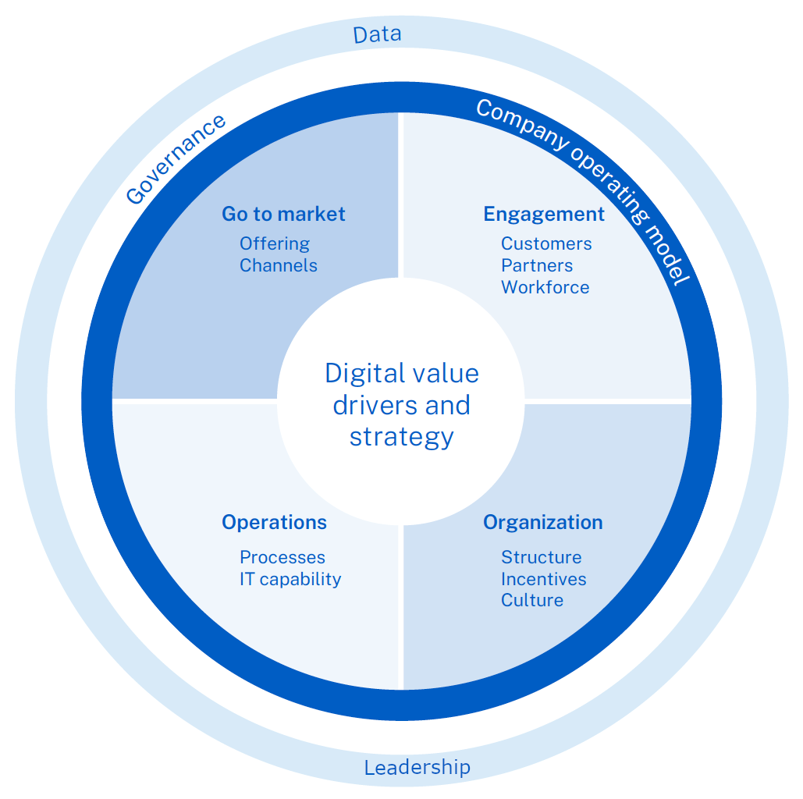
Diagram #1 - IMD’s orchestration methodology

Phase 1: Diagnostics (Approx. 1 Month: September 2025)
- Objective: Define strategic vision framework, establish baseline and define the untapped value.
- Key Activities:
  - Proposal Refinement & Project Planning: We will ensure the detailed proposal aligns with your needs, followed by concrete planning of project start and capacity.
  - Key Stakeholder Input Sessions: Plan and conduct 2-3 deep and max. 5 selected short interviews with critical stakeholders, to integrate their invaluable operational context and ideas into the early visioning process, fostering early buy-in and ownership.
  - Cause-Effect Diagrams & Improvement Actions: Diagramming cause-effect diagrams, together with colleagues from E-mobility to ensure train-the-trainer capability building.
  - High-Level Vision Formulation: Begin co-creating the overarching DSH vision, integrating both digital and hardware, and addressing foundational strategic questions like "buy versus build" and the role of AI.
  - Co-creating the approach for Phase 2.
- Key Deliverables:
  - Team Development Plan for the DSH MT
  - Detailed Current State and Aspired State Assessment, including technical, organizational, stakeholder landscape, and cause-effect analysis
  - DSH Tech Vision Framework, covering digital/hardware roadmaps, AI strategy, DSH identity
  - Market Intelligence Summary, covering competitive landscape, regulatory considerations
  - Phase 2 detailed proposal, defined in modular format with ROI rationale
- Outcome: A validated, high-level DSH tech vision and strategic framework, backed by a predefined core executive team, providing a clear compass for future development and investment, which results in more efficiency, a more effective team and better performance.

Phase 2: Co-creation of Tech Vision & Roadmap (October – December 2025)
- Objective: Establish a high-performance DSH team and develop actionable tech vision with detailed roadmaps and team alignment.
- Key Activities:
  - Executive & Broader Team Vision Workshops: Facilitated sessions will move from high-level vision to detailed strategic questions, developing clear objectives and KPIs for both digital and hardware roadmaps.
  - AI Integration & Workforce Readiness Plan: Develop a phased AI adoption plan, encompassing pilot projects, targeted training modules for workforce upskilling, and regular feedback loops to build trust and monitor adoption effectiveness, based on H3’s perpetual transformation methodology. See diagram #2 below.
  - DSH MT Journey: Dedicated efforts - within the DSH MT and beyond - to strengthen the DSH team's shared identity as the "backbone" of the e-mobility infrastructure company, transitioning to a more proactive and visionary role and adopting a high-performance way-of working within the department.
  - Addressing Cross-Functional Tensions: Targeted workshops or mediation sessions will be facilitated to surface and resolve recurring issues, particularly between DSH and procurement, aiming for a more collaborative and efficient operational framework.
- Key Deliverables:
  - DSH MT Team Charter and Team Journey flip charts
  - Complete DSH Tech Vision, including a 1-year and a 5-year horizon
  - Digital & Hardware Roadmaps, including AI integration strategy (covering Leadership, Lab, Pioneers, Tech) and a multi-year digital & hardware procurement plan
  - Success Metrics & KPI Dashboard
  - Phase 3 detailed proposal, in modular format with ROI rationale
- Outcome: A robust and actionable DSH tech vision and integrated roadmaps (digital and hardware) with a clear AI strategy. This will result in more efficiency, a more effective team and better performance.
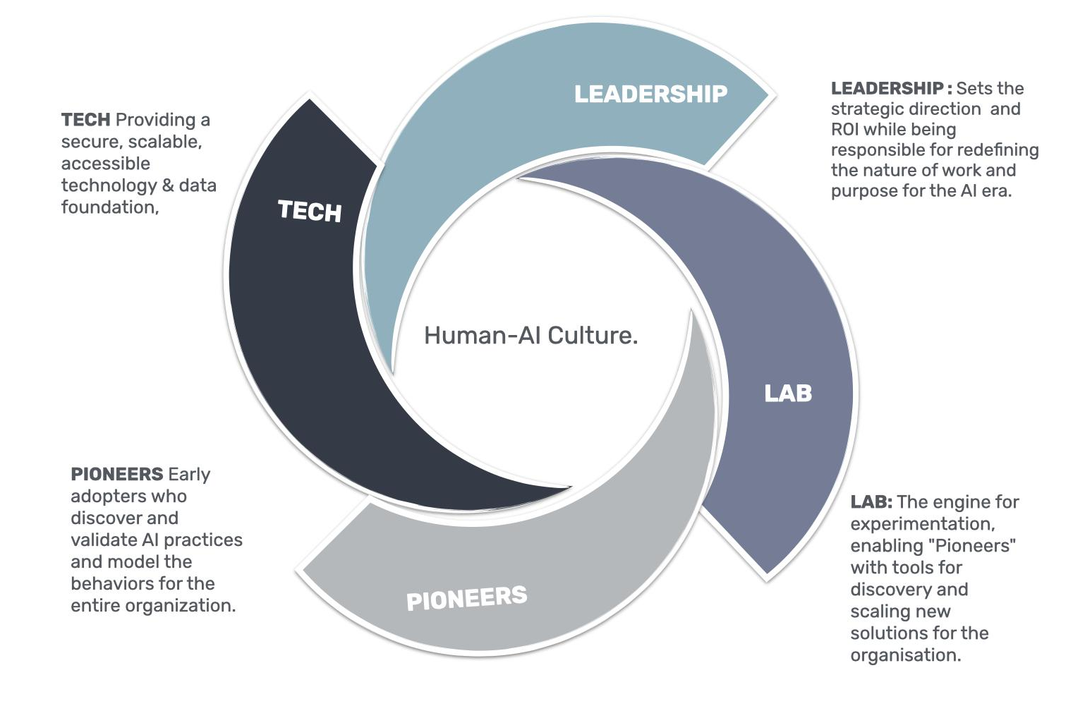
Diagram #2 - H3’s perpetual transformation methodology

Phase 3: Rollout (Starting January 2026)
- Objective: Roll out of roadmap initiatives, including building an internal AI innovation capability.
- Key Activities:
  - Architect Support: Provide targeted guidance during the initial rollout of roadmap initiatives, ensuring smooth transitions and addressing emergent challenges.
  - Leadership: Interventions to elevate AI awareness and align leadership for key stakeholders, such as the BU MT.
  - Lab: Implement an AI-innovation engine with proven frameworks and training embedding sustainable AI innovation within your organisation.
  - Pioneers: Unlock the potential of employees through interactive learning journeys that help to shift mindsets toward collaboration and transform AI-related fears into added value for the organisation.
  - Tech: Data & AI Agent Platform unifying all data and deploying a multi-agent AI architecture - potentially with embedded LLM’s. This enables intelligent insights and automated processes for key use cases like synergy tracking and customer 360, delivered via AI dashboards.
  - Sustained Governance & Review: Establish clear quarterly and annual review checkpoints within the roadmap, with defined ownership and KPIs, to continuously assess relevance and drive accountability. This leverages and refines existing operating models and governance.
- Key Deliverables:
  - Implementation playbook for AI innovation
  - Implemented governance structure including review cycles and steering committee
  - Successful implementation of numerous value-adding AI use cases
  - Further Phase 3 deliverables are to be defined in Phases 1 & 2
- Outcome: The DSH tech vision is fully integrated into business operations, the internal AI innovation capability is working seamlessly and there is sustained tech alignment throughout the BU, contributing directly to E-mobility’s competitive positioning and strategic goals.

