Input
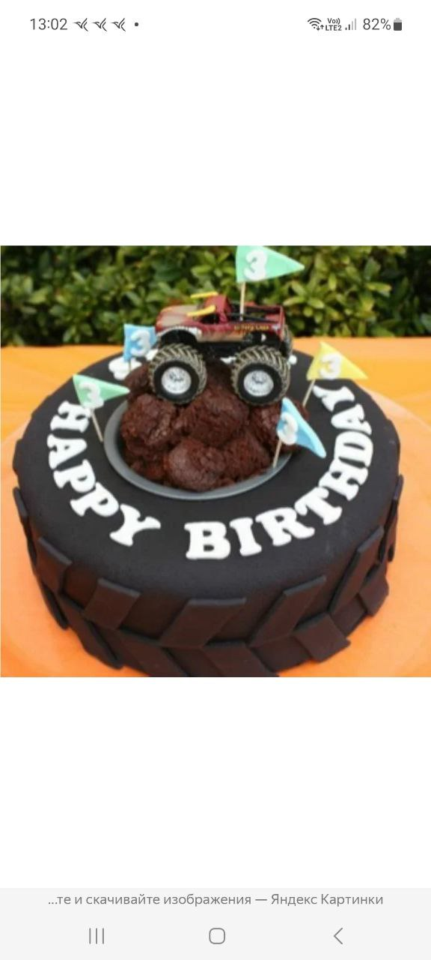

Analysis
{
"modelName": "claude-3-5-sonnet-20241022",
"result": {
"modelName": "claude-3-5-sonnet-20241022",
"status": "SUCCESS",
"processingTime": 5.14,
"responseLength": 780,
"responseType": "string",
"hasContent": true,
"error": null,
"prompt": "Analyze this image and describe what you see. Extract any text, numbers, or structured data.",
"imagePath": "D:\\Athi\\Local\\Web\\poweron\\gateway\\..\\local\\logs\\modeltest\\_test_photo.jpg",
"imageSize": 62256,
"mimeType": "image/jpeg",
"isValidJson": false,
"fullResponse": "This is a creative birthday cake designed to look like a monster truck tire/wheel. The cake appears to be chocolate-flavored and is decorated to resemble a large black tire with treads around the sides. On top of the cake, there's a mound of chocolate cake or brownie material meant to look like dirt or mud, with a toy monster truck positioned on top. The monster truck has large wheels and appears to be reddish in color. There are several small decorative flags in light blue and mint green colors stuck into the \"dirt\" mound. The words \"HAPPY BIRTHDAY\" are written in white letters around the side of the tire-shaped cake. The image appears to be from Yandex Images, as indicated by Russian text at the bottom. The status bar at the top shows 13:02 time and 82% battery level.",
"contentLength": 780,
"isStructured": false,
"savedTextFile": "D:\\Athi\\Local\\Web\\poweron\\gateway\\..\\local\\logs\\modeltest\\claude-3-5-sonnet-20241022_20251026_230732.txt"
}
}

Generation

{
"modelName": "dall-e-3",
"testTimestamp": "20251026_232425",
"testDate": "2025-10-26T23:24:25.948195",
"result": {
"modelName": "dall-e-3",
"status": "SUCCESS",
"processingTime": 22.22,
"responseLength": 2341564,
"responseType": "base64_image",
"hasContent": true,
"error": null,
"prompt": "Create a creative birthday cake designed to look like a monster truck tire/wheel. The cake appears to be chocolate-flavored and is decorated to resemble a large black tire with treads around the sides. On top of the cake, there is a mound of chocolate cake or brownie material meant to look like dirt or mud, with a toy monster truck positioned on top. The monster truck has large wheels and appears to be reddish in color. There are several small decorative flags in light blue and mint green colors stuck into the \"dirt\" mound. The words \"HAPPY BIRTHDAY\" are written in white letters around the side of the tire-shaped cake. The image appears to be from Yandex Images, as indicated by Russian text at the bottom. The status bar at the top shows 13:02 time and 82% battery level.",
"size": "1024x1024",
"quality": "standard",
"style": "vivid",
"isBase64": false,
"isValidBase64": true,
"imageByteSize": 1756173,
"responsePreview": "iVBORw0KGgoAAAANSUhEUgAABAAAAAQACAIAAADwf7zUAAA3DmNhQlgAADcOanVtYgAAAB5qdW1kYzJwYQARABCAAACqADibcQNj...",
"fullResponse": “<binary>",
"savedImageFile": "D:\\Athi\\Local\\Web\\poweron\\gateway\\..\\local\\logs\\modeltest\\dall-e-3_20251026_232425.png"
}
}

Result

