STAKEHOLDER INTERVIEW TOBIAS

Date: 29 August 2025
Attendees: Tobias, Pieter, Patrick, Jeroen

Agenda (60”):
- Framing & introductions (10” max.)
- Interview
- Next staps & wrap-up (5”)

Notes:
- Pieter’s introduction: charismatic, empathic, clear, concise, …
- Could be clearer on exact deliverables of the initiative
- Lighting is not optimal in Pieter’s room

Q2: E-mobility questions for managers from outside the BU E-mobility
- How well do you know E-mobility? Do you know the BU’s primary strategic targets?
  - BOrn inSweden
  - Mgmt consultant
  - MSc Civil Engineering, nuclear domain & reactor, then treasury dept.
  - Thomas based in Stockholm, his major team in Berlin
  - Supporting 6 categories: solar, m&c, Finance, E-mobility, hydrogen
  - 17 FTE, 6 team leads and strateg. Buyers, junior buyers too to share load incl diversity
  - I like procurement, because
    - People , great team to lead
    - In the center of transformation of industry (electrification)
    - To contribute to better world

- What is the nature of your relationship with E-mobility?
  - Before was category manager of BU E-Mob

- If at all, where and how can the collaboration between your team and E-mobility be elevated to a next level in service of Vattenfall?
  - Closely integrated already, sometimes surprised about decision and direction to jeopardize current state, to identify short-termed changes
  - Unclear changes on situations, short-term → difficult to adapt so fast to adapt better
  - Example:_ batteries to integrate into chargers → grid connections and revenue as criteria; so different solutions which lead to pressure and short termed adaptions
  - When handed over category manager role, one job was to NOT ACT until date fixed, so to prevent unused work → then acted on all initiatives, which overloads the team → creates informal leaders (Bastiaan de Jong vs. Stefano/Sven) → difficult situation then how to lead and give oversight → so to prepare answers wisely and having the pig picture, rather than just giving an answer
  - Collaborative mood? - great collaboration in super atmosphere, “special persons” now away, psycho safety awareness in the team without hidden agenda. So good clean healthy communication. Always to improve for sure.
  - To treat suppliers fair and neutral, some still preferring suppliers - this to be fixed → brand is in the core!

Q3: Tech vision & framework
- This initiative aims to develop, implement and maintain the tech vision for BU E-mobility. How would you define a tech vision?
  - Tech vision feels for me like engineering focus → i miss the link to the customer needs. No to bombard him with 1000 technical needs, away from he really wants
  - Procurement can help focussing
  - Capabilities to shape better, to focus on corporate strengths → to identify our USP
- We use a framework to cover all relevant aspects. What do you feel is missing if anything? SHOW THE STEERING WHEEL – SEE SLIDE 3
  - Culture & strategy → not to underesimate CULTURE
  - Customer to put more to FOCUS
- How strongly is digital transformation anchored in your procurement strategy, and what's your vision for procurement's role in the company's digital future?
  - Category deep dive running now → WORK IN PROGRESS

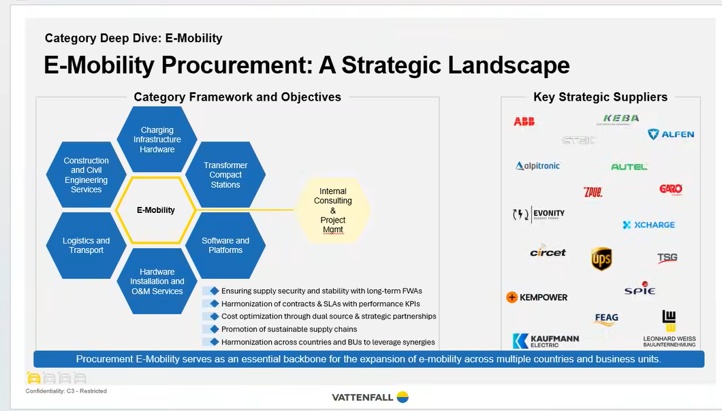

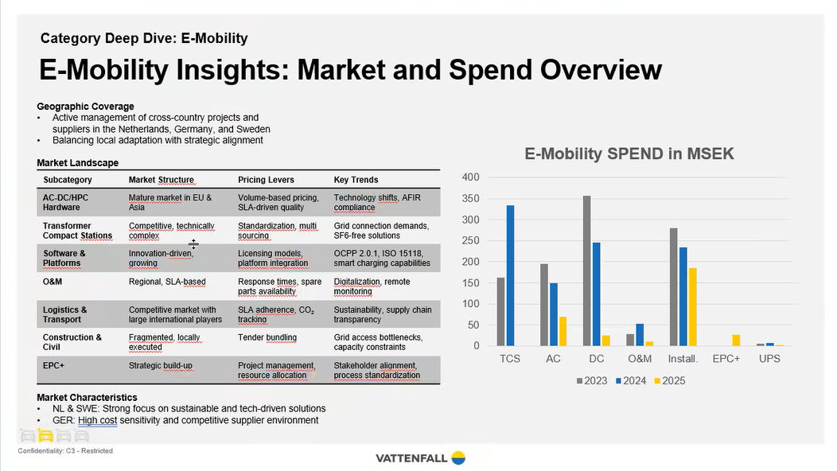

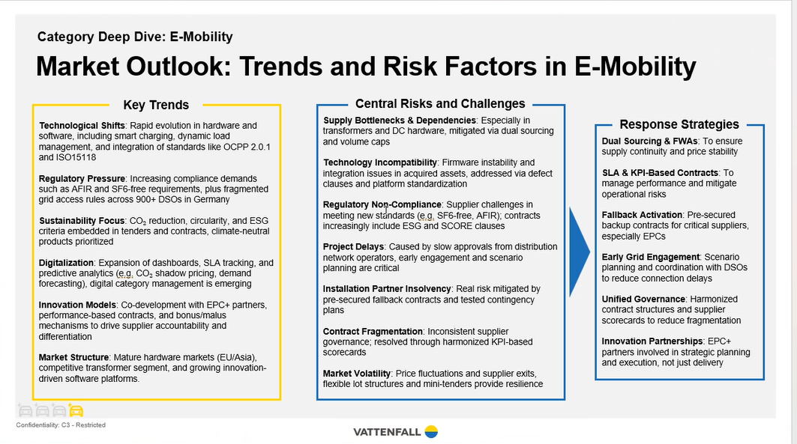
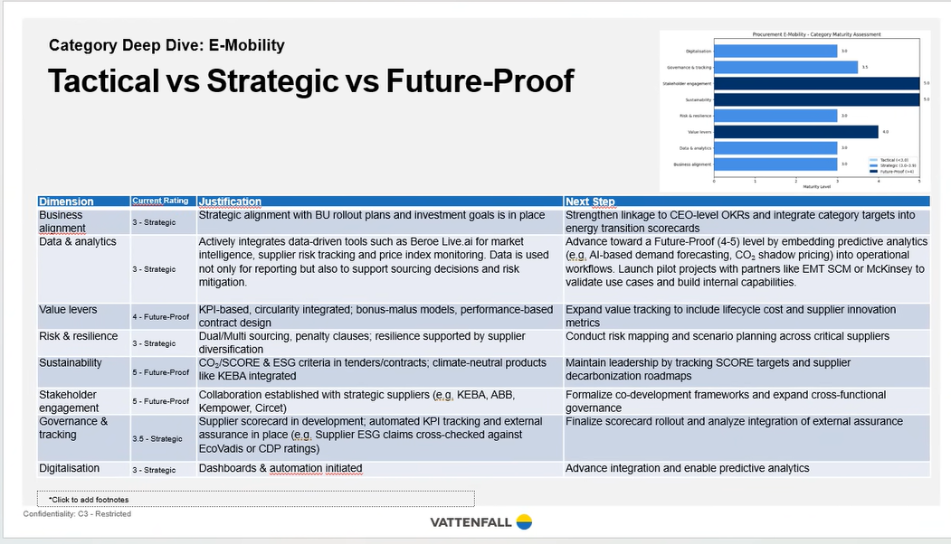

Catecory management tool, AI enabled: launched beginning of 2025, named: :-)

Q4: Procurement
- From your procurement expertise, how can strategic sourcing and supplier partnerships accelerate our business transformation?
  - Procurement has a lot of experience and a time-tested framework when it comes to identifying and managing strategic suppliers (Fast-charging and AC suppliers) → Core values: Active, open, positive space
  - ABB, Kempower, Alfen are already supported this way. The others can benefit from this
- What's your view on how procurement can enable innovation through digital supplier ecosystems and partnerships that benefit our core business?
  - If our roadmap is clearly communicated we can piggyback on an enormous amount of R&D budget on suppliers side, so that we can influence their R&D agendas in a way that helps the BU to be successful → Could be a multiplier to our R&D budgets
  - There is a lot of interest from the hardware team to explore many interesting possibilities, yet sometimes it feels like they are running without a compass.
- How can procurement's data and spend analytics provide insights that drive better business decisions across the organization?
  - Procurement already has a supplier dashboard (SBTI - scientific based target initiative).
- Based on your experience, how should we engage procurement teams to ensure they're aligned with and supporting our business transformation goals?
  - I have experienced that there was a bit more pushback for working with cat management. We now have a 5-point support approach, which has been time-tested. “Steal with pride”.
- What procurement-driven value creation opportunities do you see that could strengthen our overall business strategy and benefit our internal customers?
  - Cooperation between Susanna Hurtig and Network Solutions was not helping in the past, lack of focussing on the bigger picture, that was annoying and I could not support that. Some individuals are still there and this has affected the relationships. Intercompany margins is not for procurement to get involved with.
5. Conclusion:
- Anything else? Focus on Change Management → there is a lot going on within BU E-mobility. There may be a few who think “there we go again”. It is important to take that into account.

Do you have anything else to add in this context? Anything we missed?
– change management to understand and to have a clear process

Interviewers: Thank the interviewee → Pieter

